Section I: Scenario Demographics

Scenario Title: | Massive Pulmonary Embolism
Date of Development: | 08/06/2015 (DD/MM/YYYY)
Target Learning Group: | Juniors (PGY 1 – 2) Seniors (PGY ≥ 3) All Groups

Section II: Scenario Developers

Scenario Developer(s): | Kyla Caners
Affiliations/Institution(s): | McMaster University
Contact E-mail (optional): | kcaners@gmail.com

Section III: Curriculum Integration

Learning Goals & Objectives
Educational Goal: | To enhance resuscitation and team management skills using a pulmonary embolism case which requires difficult management decisions to be made quickly.
CRM Objectives: | Lead team members effectively through a challenging resuscitation.
Medical Objectives: | - Recognize risk for PE and initiate the appropriate workup urgently.  - Provide quality ACLS care, including:  - Using ETCO2 to guide resuscitation  - Minimizing pulse checks  - Appropriate 30:2 compressions: breaths ratio  - Appropriate use of medications (epinephrine and thrombolytic)  - Consider the administration of thrombolytics during cardiac arrest secondary to a suspected pulmonary embolism.

Case Summary: Brief Summary of Case Progression and Major Events
A 46 year old male with a cast on his left leg from a bad ankle fracture presents to the ED complaining of pleuritic chest pain and shortness of breath. The team will take a history and start workup when the patient will suddenly state he’s “not feeling well” and then arrest. The team will perform ACLS consistent with the PEA algorithm and should consider IV thrombolytics. If IV thrombolytics are administered, the patient will have ROSC.

References
Marx, J. A., Hockberger, R. S., Walls, R. M., & Adams, J. (2013). Rosen's emergency medicine: Concepts and clinical practice. St. Louis: Mosby.

Section IV: Scenario Script

A. Scenario Cast & Realism
Patient: | Computerized Mannequin |  |  |  |  | Realism:  Select most important dimension(s) |  |  | Conceptual
 | Mannequin |  |  |  |  |  |  |  | Physical
 | Standardized Patient |  |  |  |  |  |  |  | Emotional/Experiential
 | Hybrid |  |  |  |  |  |  |  | Other:
 | Task Trainer |  |  |  |  |  |  |  | N/A
Confederates | Brief Description of Role
None. | A distraught wife could be added to the scenario to make the case more complex for senior learners.
B. Required Monitors
EKG Leads/Wires |  |  | Temperature Probe |  |  |  | Central Venous Line
NIBP Cuff |  |  | Defibrillator Pads |  |  |  | Capnography
Pulse Oximeter |  |  | Arterial Line |  |  |  | Other:
C. Required Equipment
Gloves |  |  | Nasal Prongs |  |  |  | Scalpel
Stethoscope |  |  | Venturi Mask |  |  |  | Tube Thoracostomy Kit
Defibrillator |  |  | Non-Rebreather Mask |  |  |  | Cricothyroidotomy Kit
IV Bags/Lines |  |  | Bag Valve Mask |  |  |  | Thoracotomy Kit
IV Push Medications |  |  | Laryngoscope |  |  |  | Central Line Kit
PO Tabs |  |  | Video Assisted Laryngoscope |  |  |  | Arterial Line Kit
Blood Products |  |  | ET Tubes |  |  |  | Other:
Intraosseous Set-up |  |  | LMA |  |  |  | Other:
D. Moulage
Cast on left lower leg to simulate ankle fracture.

E. Approximate Timing
Set-Up: |  | 5 min |  | Scenario: | 12 min |  |  | Debriefing: |  | 15 min

Section V: Patient Data and Baseline State

A. Clinical Vignette: To Read Aloud at Beginning of Case
A 46 year old male presents to the ED complaining of shortness of breath and pleuritic chest pain. He broke his ankle a week ago and has been in a cast since. He was just discharged home after operative repair 2 days ago.
B. Patient Profile and History
Patient Name: Vinny Kostas |  |  |  |  |  | Age: 46 |  |  |  |  |  |  |  | Weight: 70kg
Gender: M F |  |  |  |  |  | Code Status: Full.
Chief Complaint: SOB
History of Presenting Illness: Twelve hours of worsening shortness of breath. Feels like it’s hard to catch his breath and it gets worse when he walks. For the last two hours, he’s also been having sharp, pleuritic chest pain to the right side of his chest. He’s never experienced anything like this before.
Past Medical History: |  | Recent ankle # with ORIF |  |  |  |  | Medications: |  |  |  |  | Tylenol #3 PRN
Allergies: None.
Social History: Non-smoker.
Family History: Dad has clotting disorder. Unsure what it is – makes his blood thick?
Review of Systems: |  | CNS: |  |  | Nil.
 |  | HEENT: |  |  | Nil.
 |  | CVS: |  |  | Chest pain. Pleuritic and sharp. Across his right chest. No orthopnea or PND.
 |  | RESP: |  |  | Feel SOB. Worse when he’s walking.
 |  | GI: |  |  | Nil.
 |  | GU: |  |  | Nil.
 |  | MSK: |  |  | His casted leg hurts. |  |  |  |  |  |  |  | INT: |  | Nil.
C. Baseline Simulator State and Physical Exam
No Monitor Display |  |  |  | Monitor On, no data displayed |  |  |  |  |  |  | Monitor on Standard Display
HR: 115/min |  |  | BP: 95/60 |  |  |  |  | RR: 18/min |  |  |  |  |  |  | O₂SAT: 92%
Rhythm: Sinus tach |  |  | T: 37.2ºC |  |  |  |  | Glucose: 6.3 mmol/L |  |  |  |  |  |  | GCS: 15 (E4 V5 M6)
General Status: Looks relatively well.
CNS: | A+O. PERLA. No FND.
HEENT: | Nil.
CVS: | Normal S1/S2. No murmur.
RESP: | Good air entry bilaterally. No adventitious. Mildly tachypneic.
ABDO: | Soft, non-tender.
GU: | Nil.
MSK: | Left leg in cast. No other hot/tender joints. |  |  |  |  |  |  |  | SKIN: | Nil.

Scenario States, Modifiers and Triggers
Patient State | Patient Status | Learner Actions, Modifiers & Triggers to Move to Next State
1. Baseline State  Rhythm:  HR: 115/min  BP: 95/60  RR: 18/min  O₂SAT: 92% RA  T: 37.2ºC | A+O. Complaining of pleuritic CP and SOB. | Learner Actions  - IV, O2, monitors  - ECG  - Cardiac blood work, D dimer  - History and Physical  - Order CT chest  - ± Cardiac U/S for RV strain | Modifiers  Changes to patient condition based on learner action  Triggers  For progression to next state  - 2 min 2. PEA Arrest
2. PEA Arrest  Rhythm slow PEA  HR 20  BP -/-  O₂SAT 68%  ETCO₂ 10 | Patient states that he doesn’t feel well the becomes suddenly unconscious and pulseless.  Senior Case (Optional)  Wife arrives at 6 min mark and is hysterical | Learner Actions  - Quality CPR (30:2 until intubation)  - Epinephrine 1amp q3min  - ± HCO3 and CaCl amps  - Intubate  - Monitor capnography  - Consider thrombolytics (eg: TNK 50mg iv bolus)  - Confirm dosing with local protocol/pharmacy/thrombo  Senior Case (Optional)  - Delegate team member to talk to wife, calm her, and explain resuscitation process | Modifiers  - Quality CPR: ETCO2 16  - Poor CPR: ETCO2 8  Triggers  - 3 min after thrombolytics given  3. ROSC  - 12 min End Case
3. ROSC  Rhythm NSR  HR 85  BP 85/45  O₂SAT 96%  RR 12 (vented)  ETCO₂ 40 | Patient nonresponsive but has pulse | Learner Actions  - ECG, check cap sugar (6.3)  - Norepi or epi infusion  - ± Initiate cooling  - CXR  - Continue thrombolytic infusion (if tPA used)  - Consult ICU | Modifiers  - Vasopressor started BP 95/65  Triggers  - 12 min End Case
Section VI: Scenario Progression

Section VII: Supporting Documents, Laboratory Results, & Multimedia

Laboratory Results
None required for case.

Images (ECGs, CXRs, etc.)
ECG – Sinus tach with RBBB & TWI V1-V3 (RV strain)  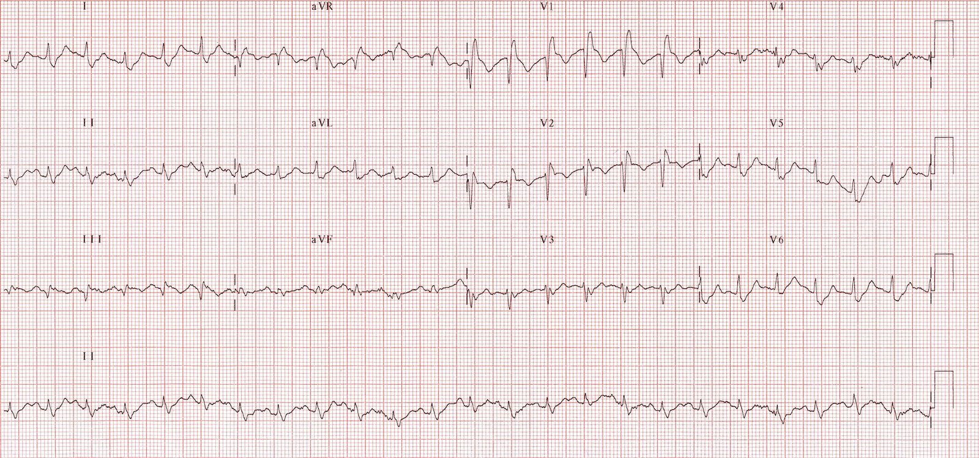  http://cdn.lifeinthefastlane.com/wp-content/uploads/2011/12/ECG-Massive-PTE.jpg | CXR – normal post-intubation male  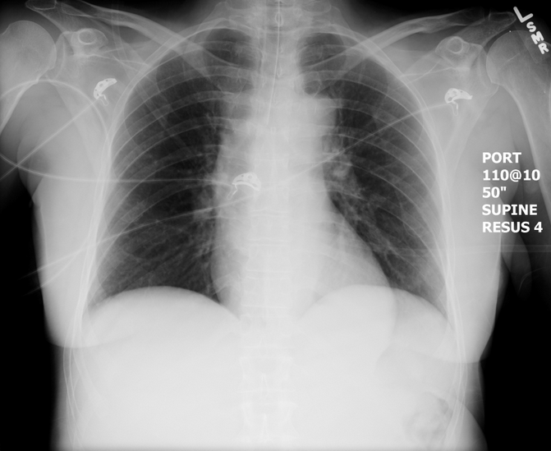  https://emcow.files.wordpress.com/2012/11/normal-intubation2.jpg
Ultrasound Video Files (if applicable)
U/S Showing RV strain (if done when cardiac activity) | U/S showing cardiac standstill (if done during arrest)

Section VIII: Debriefing Guide

General Debriefing Plan
Individual | Group |  | With Video | Without Video
Objectives
Educational Goal: |  | To enhance resuscitation and team management skills using a pulmonary embolism case which requires difficult management decisions to be made quickly.
CRM Objectives: |  | Lead team members effectively through a challenging resuscitation.
Medical Objectives: |  | - Recognize risk for PE and initiate the appropriate workup urgently.  - Provide quality ACLS care, including:  - Using ETCO2 to guide resuscitation  - Minimizing pulse checks  - Appropriate 30:2 compressions: breaths ratio  - Appropriate use of medications (epinephrine and thrombolytic)  - Consider the administration of thrombolytics during cardiac arrest secondary to a suspected pulmonary embolism.
Sample Questions for Debriefing
- How did it feel to lead the team through this resuscitation? How did it feel to make the hard call on thrombolytics?
- How did the team feel about the way the leader approached the thrombolytics option?
- What are markers of quality arrest care?
- What are the indications for thrombolytics in PE?
Key Moments
Recognizing possible PE.
Coordinating arrest care.
Decision to administer thrombolytics.

